Concentrations Documentation
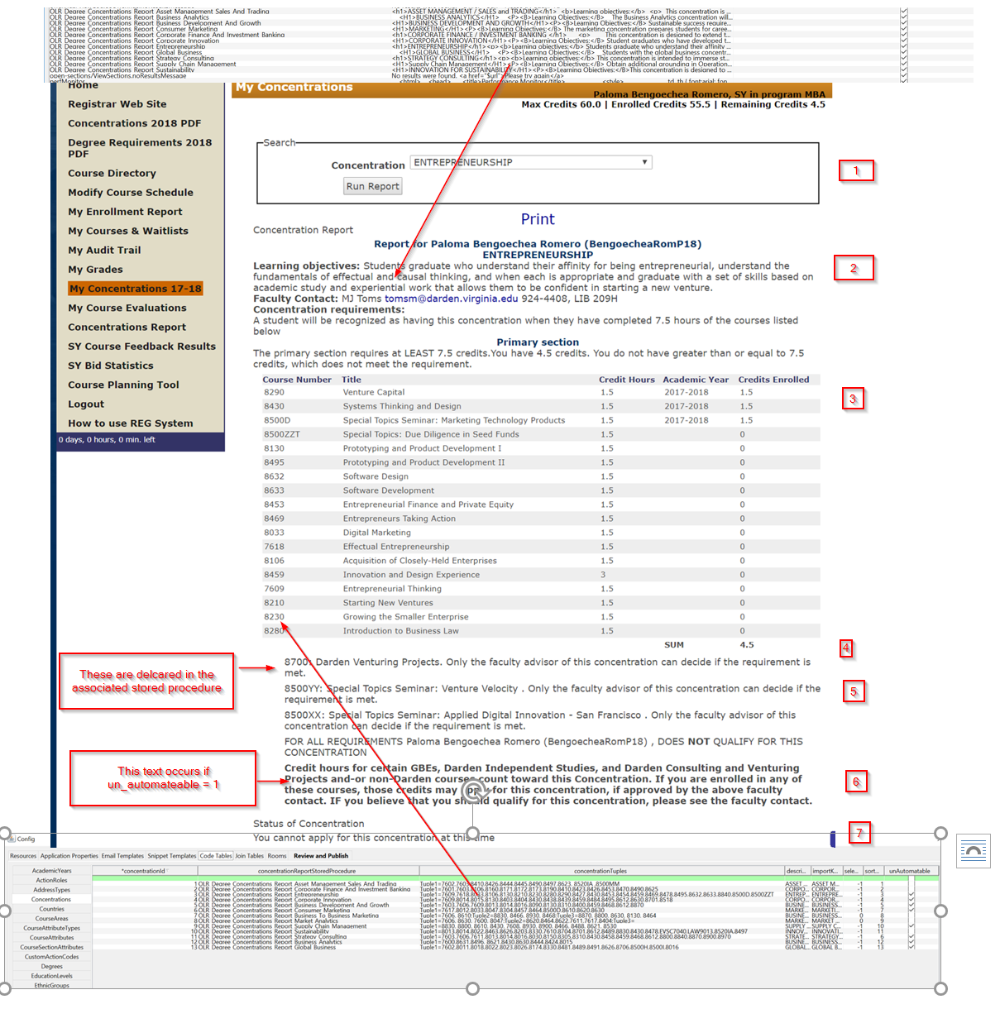
- Concentrations shown are those with “currentConcentrationsMask” set in admin. So this is configurable as to which ones are shown
- The snippet is configurable based on admin OLR_Snippet_Templates
- The course numbers in the left column come from the list of OLR_COURSE_OFFERINGS that match the list of course numbers passed in tuple1 (Tuple1=7602,7603,8410…) where they have credit_hours > 0 and they are in the configured academic years ('degreeConcentrationsQueryOneAcademicYearId', 'degreeConcentrationsQueryTwoAcademicYearId'). The system builds up a distinct list of course_desription_ids associated with the course_numbers passed in. It then joins on the course_description_id to get the users enrollment where they have an action_role_id= degreeConcentrationsQueryThreeActionRoleId application property. (a user can only be enrolled once in an offering)
  - If a student does not have the degreeConcentrationsQueryThreeActionRoleId then they will not see any of their courses under credit hours.
  - If a course has no record in OLR_COURSE_OFFERINGS then it will not show up
  - A course number in the list of Tuple1 can only be associated with one course description. (For example, 8500D and 8500XX are both in Entrepreneurship but derive from the same course description [one must go in the bottom of the report]).
  - If a single course number is associated with greater than one course description then it must be in the bottom of the report.
  - A course number must have the same credits across the two academic years configured
  - Business Analytics all must apply based on Carraway’s requirements
- The credits are configured in the associated concentration stored procedure
- The bottom course numbers are configured in the associated concentration stored procedure, and if there is more than one offered in the academic years it takes the first
- This text is shown based on whether un_automateable=true=1
- Students can apply when the current time is between the ‘degreeConcentrationsStudentSubmitBeginTime’ and degreeConcentrationsStudentSubmitEndTime. To apply from the report they must click through and re-run the report.
The concentrations report is a little slow (runs in < 10 seconds), but it is doing a lot of work for the user. I did a simple load test on the report, running a few users at a time: it will not be under heavy load like add/drop.

Technical Stuff
- I ran the sql profiler on this and added a few indexes to speed things up.
- I wrote two helping stored procedures that will help you when you edit a course
exec OLR_Degree_Concentrations_Report_Check_Concentration <concentration_id>
exec OLR_Degree_Concentrations_Report_Check_Concentration_By_Year <concentration_id>

