Registrar Setup For Upload
Each course section must have a unique export key, WITH NO SPACES, and a default grade scale.
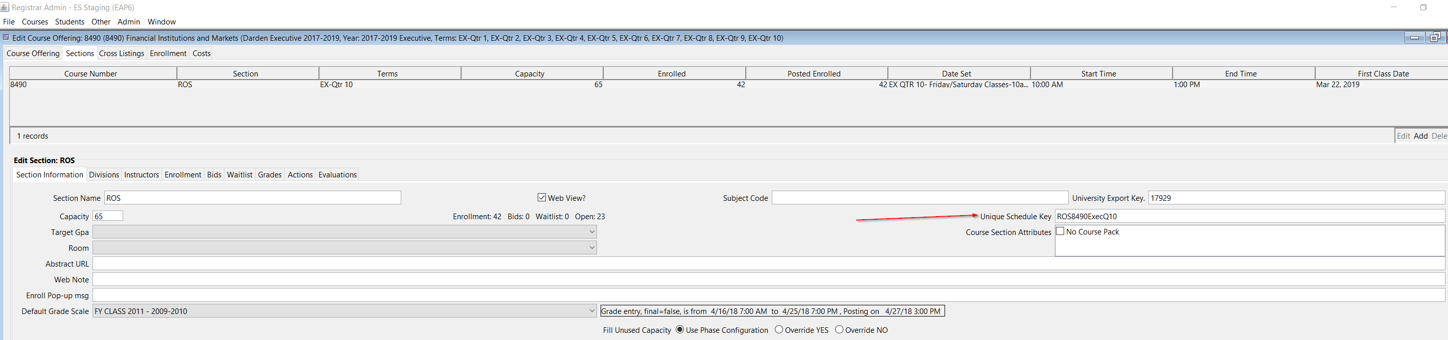
Each grade scale must have an import key, WITH NO SPACES,
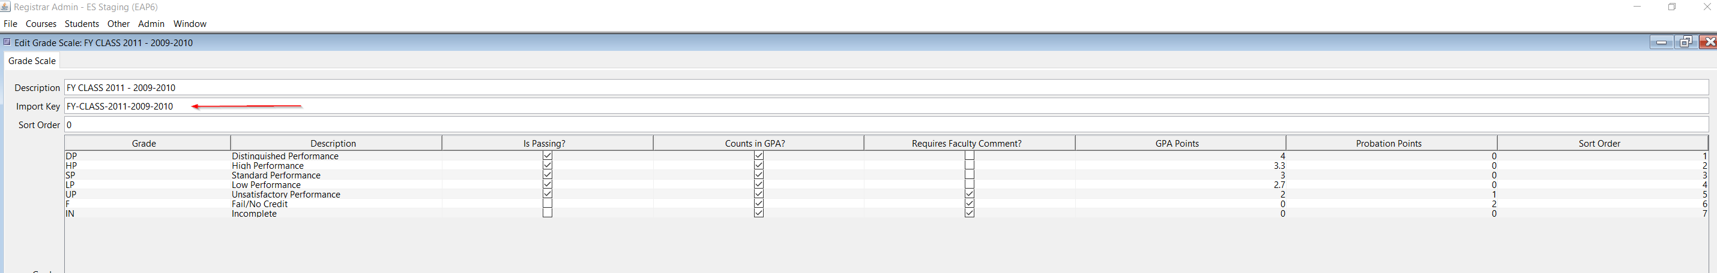

Make sure the application property HideImportEnrollmentFromCSVForFaculty is false

Process allowing TA’s to upload grades
- You can watch a video at https://screencast-o-matic.com/watch/cqei2R0OgG
- Go to Course at website and get abbreviated csv
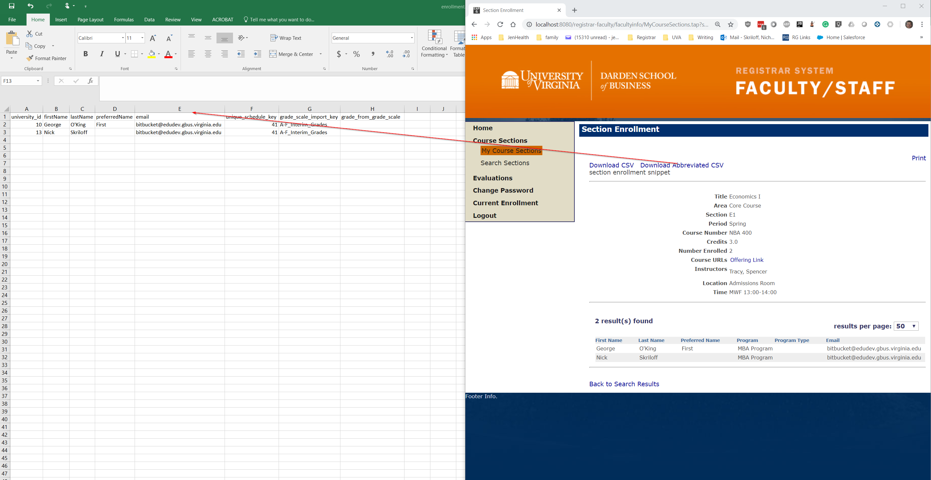

Only these 4 columns should be there for upload
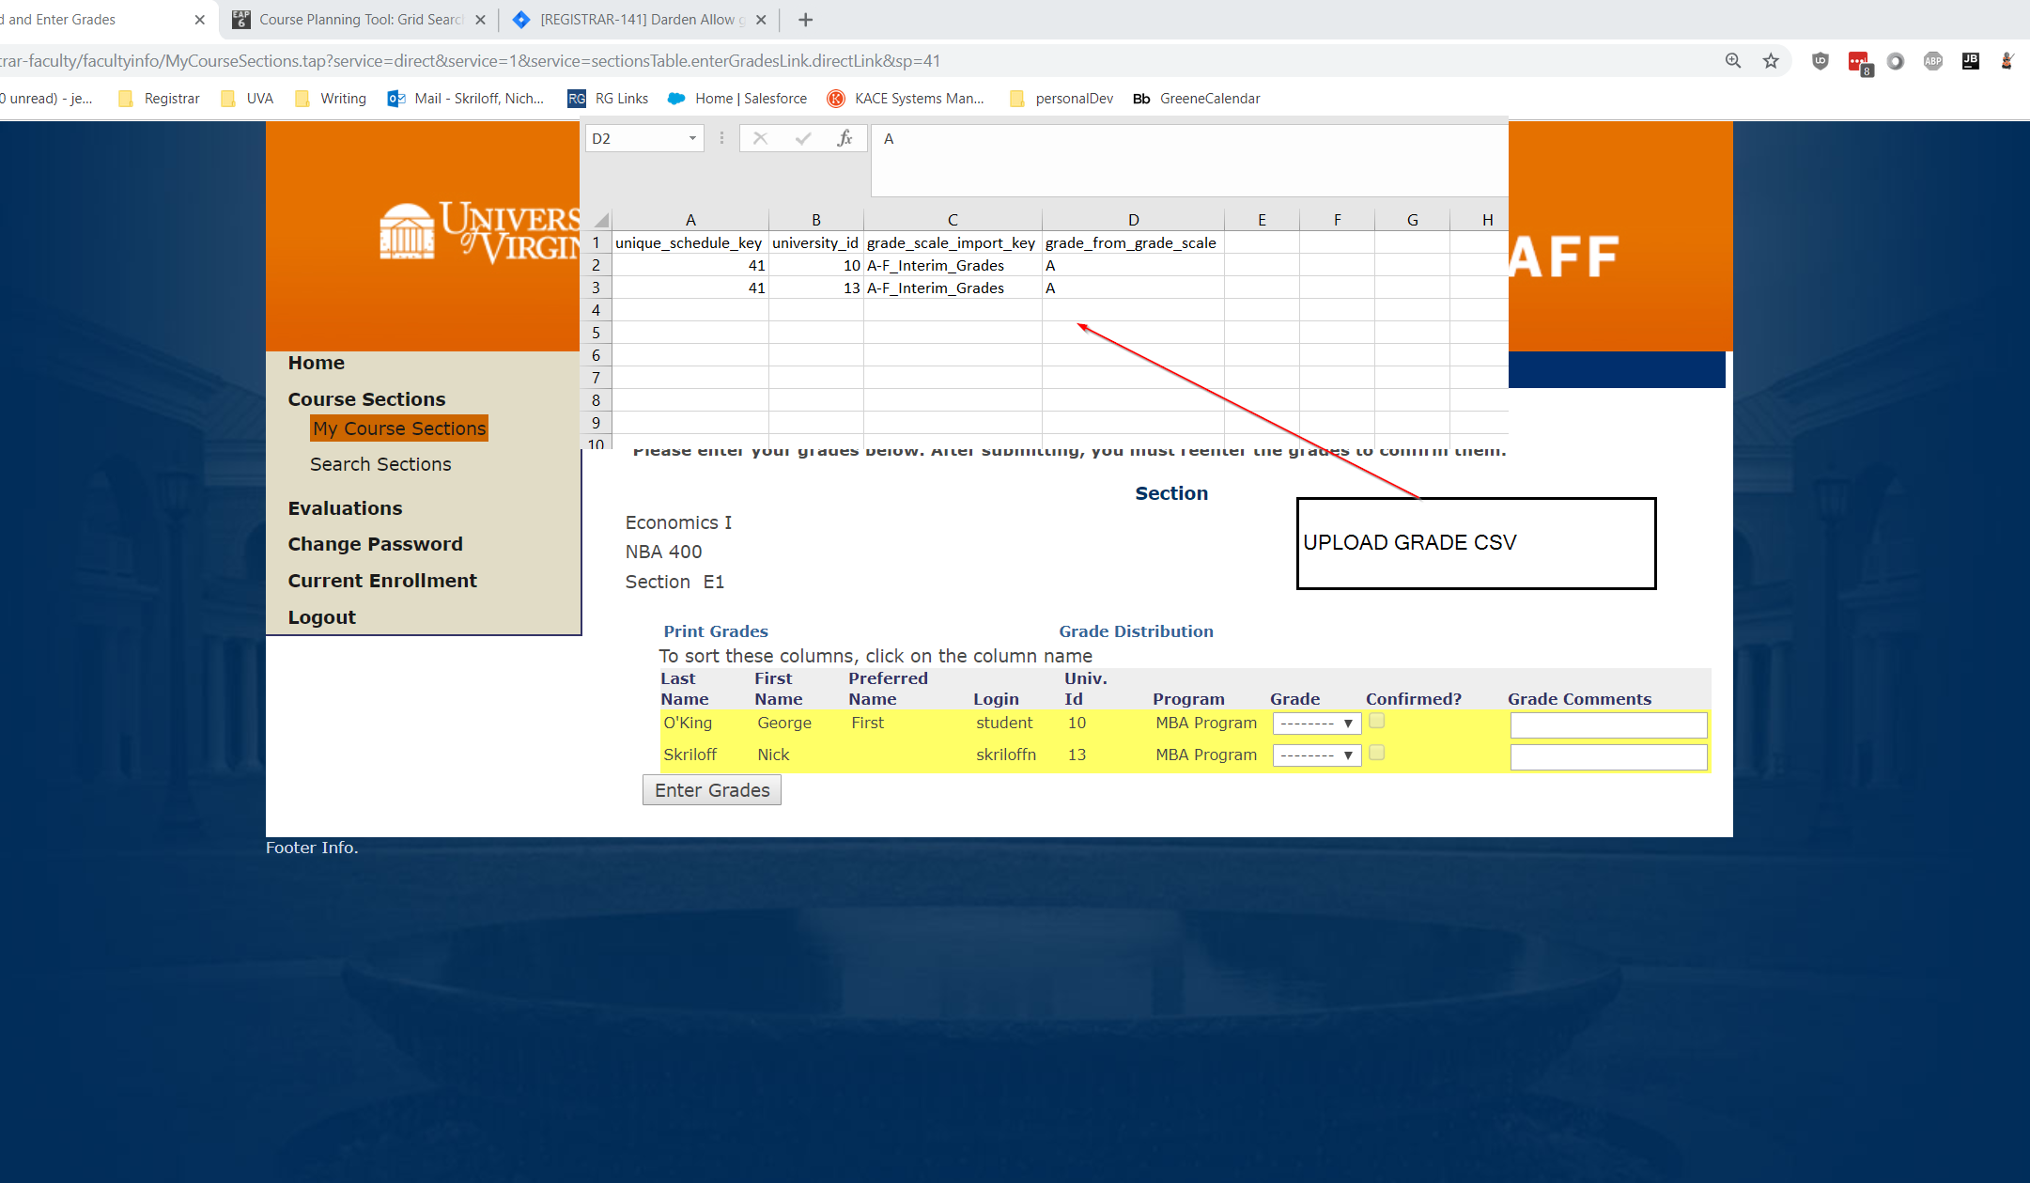
After uploading the document this verbiage comes back. If there is an error, you will see it in RED. See Wendy about these.

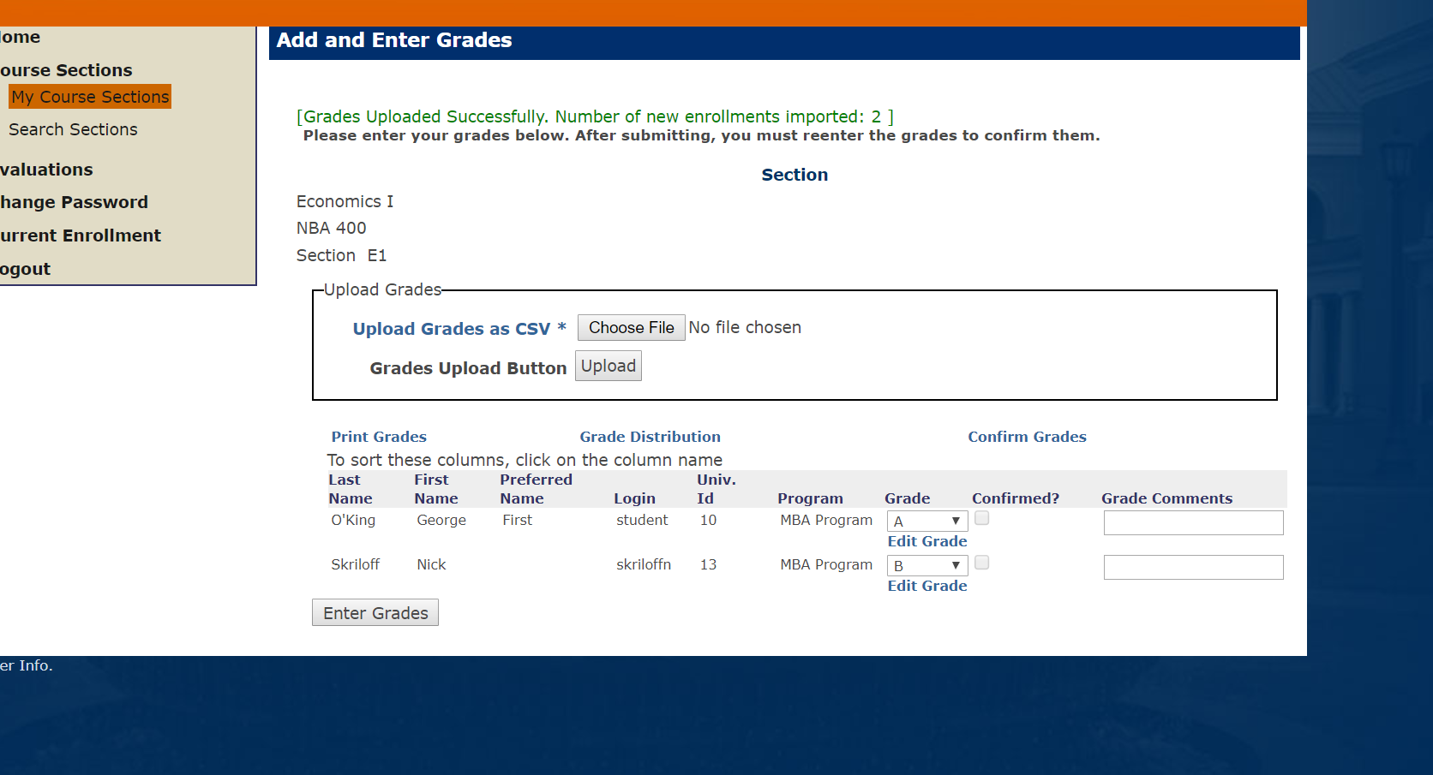

You can change one grade and it will just update that one grade.
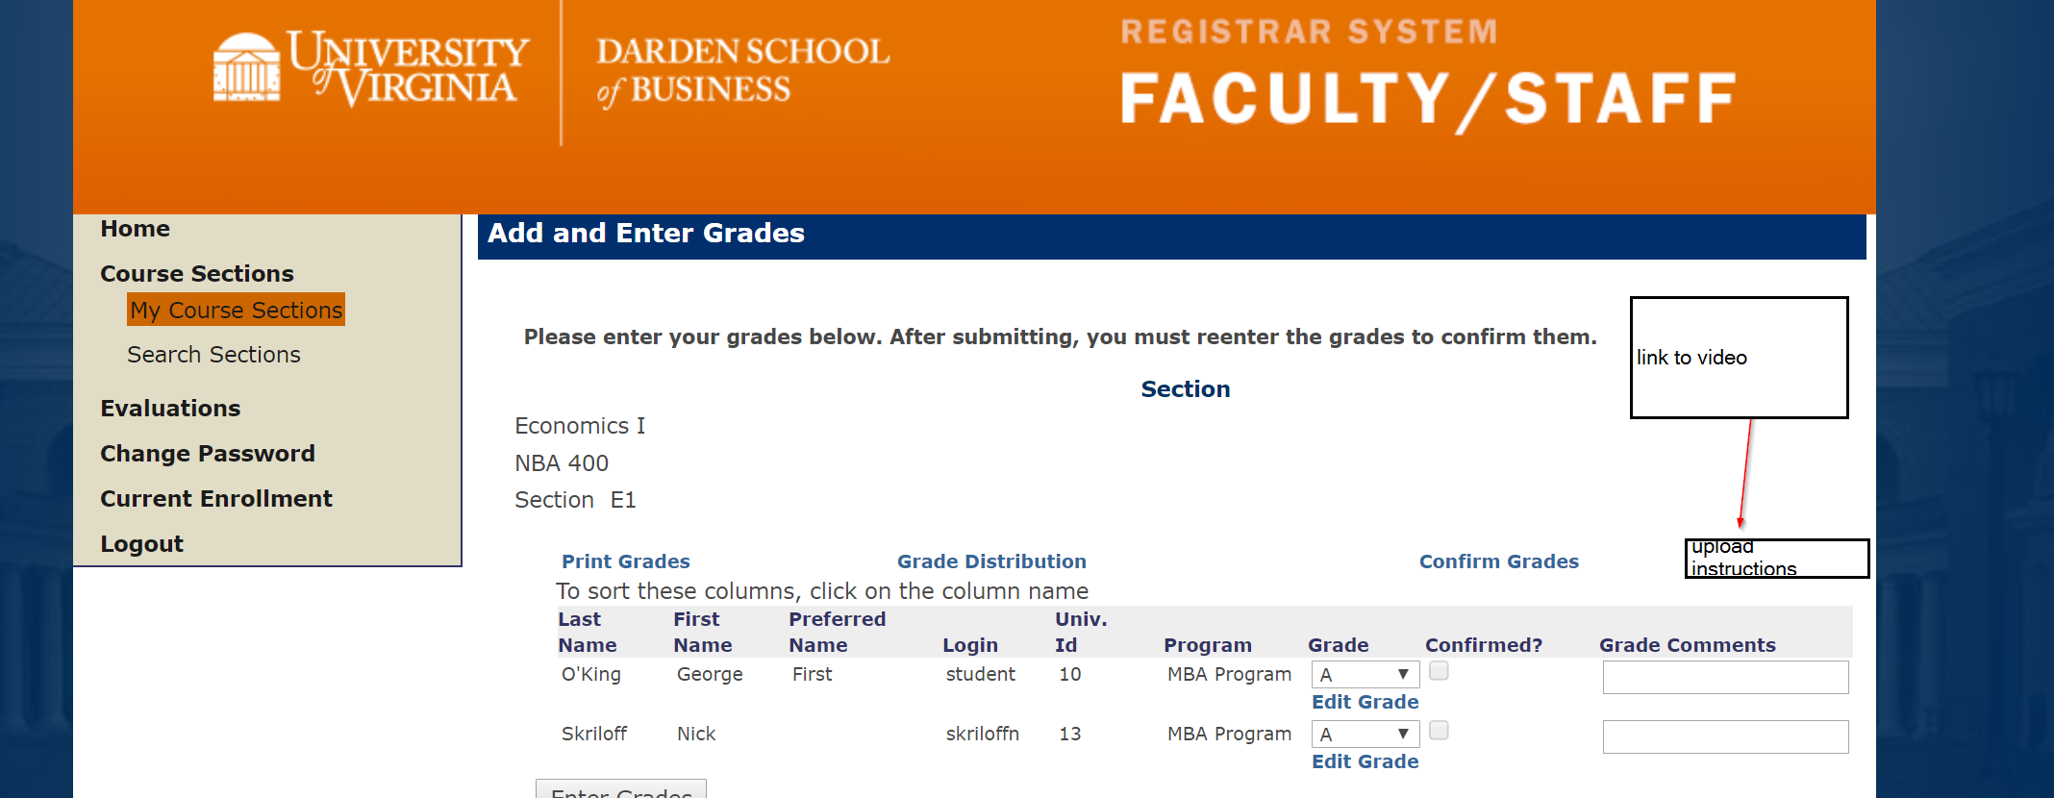

Moving forward
* Nick and Wendy sign off
* Small group Testing of this who become the AA advocate trainers
* Training session after small group testing sign off
* Goal timeline (flexible) Aggressive Goal is March 15th and a low goal is May 15

Technical Documentation (TAs ignore the below)
Currently Darden admins do not use the import procedure but other schools do. That is controlled by the application property 'RequireGradesInImportEnrollmentFromCSV'. So toggle to allow admins.
Decision: Wendy agrees to work with a few AAs to be first level support for questions on the CSV
Decision was made that if you change a grade that it should not affect all grades. So, we copied the values in. We should have just let the user know that they would change all grades? The grade_scale_import key is copied in to OLR_Student_Grades that represents the value at the time the grade is created. The OLR_Student_Enrollment Table has the grade_scale_id.
See OLR_Application_Properties set string_value = 'true' where name in ('RequireGradesInImportEnrollmentFromCSV','ShortLoggingLevelForImportEnrollmentFromCSV','DoNotConfirmGradesAutomaticallyForImportEnrollmentFromCSV',’GradeImportDoesNotIncludeEnrollments’);
On 2/28/20, Pete Brecht added the application property, GradeImportDoesNotIncludeEnrollments, which is noted in https://darden.atlassian.net/browse/DSI-98

